**PF Lab 3**

**Instructions**

You are required to submit a zipped folder(named: yourNollNumber) containing the pdf/word file of section 1 and firstProgram.cpp file of section 2 & 3. Please note that there will be a 20 minute lecture in the end. Therefore, complete your work on time.

**Section 1**

Read & understand pages 1 to 6. Run all the given commands and attach the screenshots in a single pdf/word file.

**Section 2**

1. Type **cd** command, it will take you to the home directory, after that use **ls** command, then use **cd Desktop** to change the current directory.
2. Here make a new directory **(named: yourRollNumber)** using **mkdir** command. Then use **cd** command to navigate into the newly created directory.
3. Now create a file *firstProgram.cpp*
4. Now open this file with this command **open** *firstProgram***.**cpp
5. Write down the following code in the recently opened file. Don’t worry about the content for now.

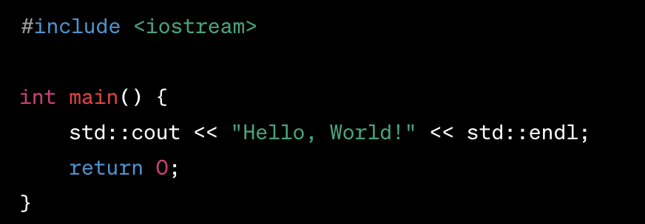

1. At this point, you have written your first C++ program, now it’s time to compile it with the following command.

**g++ filename.cpp -o outputFile**

If there is a need to install g++, install it with **sudo apt install g++**

1. If your code has been compiled successfully, it’s time to run it.

**./outputFile**

1. If you get the “hello world” output on terminal, congratulations you are a programmer now.

**Section 3**

Now make another file section3.cpp, write the following code then compile and run it. Pleae note that there are two images.Try to understand the code.

